HR SCHEMA
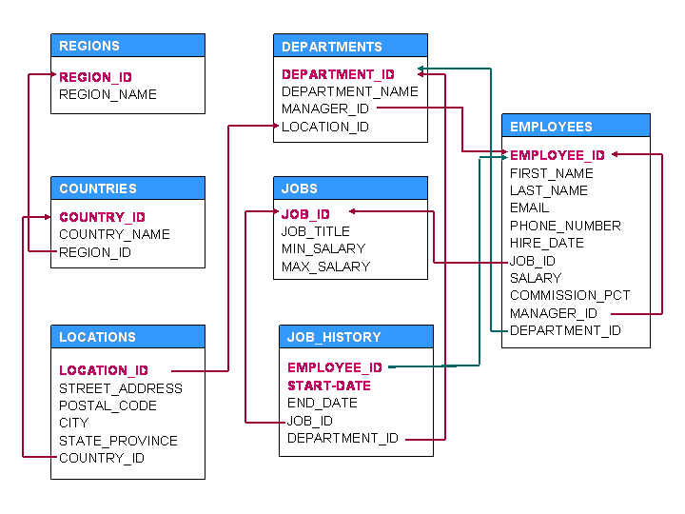

- Display details of jobs where the minimum salary is greater than 10000.
- Display the first name and join date of the employees who joined between 2002 and 2005.
- Display first name and join date of the employees who is either IT Programmer or Sales Man.
- Display employees who joined after 1st January 2008.
- Display details of employee with ID 150 or 160.
- Display first name, salary, commission pct, and hire date for employees with salary less than 10000.
- Display job Title, the difference between minimum and maximum salaries for jobs with max salary in the range 10000 to 20000.
- Display first name, salary, and round the salary to thousands.
- Display details of jobs in the descending order of the title.
- Display employees where the first name or last name starts with S.
- Display employees who joined in the month of May.
- Display details of the employees where commission percentage is null and salary in the range 5000 to 10000 and department is 30.
- Display first name and date of first salary of the employees.
- Display first name and experience of the employees.
- Display first name of employees who joined in 2001.
- Display first name and last name after converting the first letter of each name to lower case and the rest to upper case.
select CONCAT(LOWER(LEFT(FIRST_NAME,1)), UPPER(SUBSTR(FIRST_NAME,2,LENGTH(FIRST_NAME))))
AS NEW_NAME FROM EMPLOYEES;
- Display the first word in job title.
- Display the length of first name for employees where last name contain character ‘b’ after 3rd position.
- Display first name in upper case and email address in lower case for employees where the first name and email address are same irrespective of the case.
- Display employees who joined in the current year.
- Display the number of days between system date and 1st January 2011.
- Display how many employees joined in each month of the year 1997.
- Display manager ID and number of employees managed by the manager.
- Display employee ID and the date on which he ended his previous job.
- Display number of employees joined after 15th of the month.
- Display the country ID and number of cities we have in the country.
- Display average salary of employees in each department who have commission percentage.
- Display job ID, number of employees, sum of salary, and difference between highest salary and lowest salary of the employees of the job.
- Display job ID for jobs with average salary more than 10000.
- Display years in which more than 10 employees joined.
- Display departments in which more than five employees have commission percentage.
- Display employee ID for employees who did more than one job in the past.
- Display job ID of jobs that were done by more than 3 employees for more than 100 days.
- Display department ID, year, and Number of employees joined.
- Display departments where any manager is managing more than 5 employees.
- Display department name and number of employees in the department.
- Display job title, employee ID, number of days between ending date and starting date for all jobs in department 30 from job history.
- Display department name and manager first name.
- Display country name, city, and department name.
- Display job title, department name, employee last name, starting date for all jobs from 2000 to 2005.
- Display job title and average salary of employees
- Display job title, employee name, and the difference between maximum salary for the job and salary of the employee.
- Display last name, job title of employees who have commission percentage and belongs to department 30.
- Display details of jobs that were done by any employee who is currently drawing more than 15000 of salary.
- Display department name, manager name, and salary of the manager for all managers whose experience is more than 5 years.
- Display employee name if the employee joined before his manager.
- Display employee name, job title for the jobs employee did in the past where the job was done less than six months.
- Display employee name and country in which he is working.
- Display department name, average salary and number of employees with commission within the department.
- Display the month in which more than 5 employees joined in any department located in Sydney.
- Display details of departments in which the maximum salary is more than 10000.
- Display details of departments managed by ‘Smith’.
- Display jobs into which employees joined in the current year.
- Display employees who did not do any job in the past.
- Display job title and average salary for employees who did a job in the past.
- Display country name, city, and number of departments where department has more than 5 employees.
- Display details of manager who manages more than 5 employees.
- Display employee name, job title, start date, and end date of past jobs of all employees with commission percentage null.
- Display the departments into which no employee joined in last two years.
- Display the details of departments in which the max salary is greater than 10000 for employees who did a job in the past.
- Display details of current job for employees who worked as IT Programmers in the past.
- Display the details of employees drawing the highest salary in the department.
- Display the city of employee whose employee ID is 105.
- Display third highest salary of all employees
- Display sum of salary of each department and calculate subtotals across each department also calculate the grand total.

SELECT DEPT_ID, SUM(SALARY)
FROM EMPLOYEES
GROUP BY DEPT_ID WITH ROLLUP;
- Display sum of salary of each department and calculate subtotals across each department and jobs. Also calculate the grand total.

SELECT DEPT_ID, SUM(SALARY)
FROM EMPLOYEES
GROUP BY DEPT_ID, JOB_ID WITH ROLLUP;

